National University of Computer & Emerging Sciences
Computer Science Department
Course Code: CL-2006 | Course: Operating System Lab
Instructor: Yasir Arfat | Semester: Spring 2025
Lab Manual – 05
Process Management, fork(), exec()
& Zombie/Orphan Processes

Table of Contents
Table of Contents 2
Objectives 3
Concepts 4
What is a Linux Process? 4
Process ID (PID) 4
What are System Calls? 5
Types of System Calls 5
Windows vs Unix System Calls 5
The fork() System Call 7
How fork() Works 7
Example 1: Basic fork() with Process IDs 9
Example 2: Separate Address Spaces 10
Example 3: Creating Multiple Child Processes 10
System Calls to Get Process IDs 12
Zombie and Orphan Processes 12
Zombie Process 12
Example 4: Creating a Zombie Process 12
Solution: Prevent Zombies with wait() 13
Orphan Process 15
Example 5: Creating an Orphan Process 15
The exec() System Call 16
The execl() Function 16
Example 6: Simple exec() 16
Example 7: fork() + exec() Together 16
Process System Calls – Quick Reference 18

Objectives
This lab introduces you to Linux process management – one of the most important topics in operating systems. By the end of this lab, you will be able to:
- Understand what a process is and how Linux manages running programs
- Use commands like ps, pidof, and pstree to view running processes
- Create new processes using the fork() system call in C
- Get process IDs using getpid() and getppid()
- Use the wait() system call to synchronize parent and child processes
- Replace a process image using the exec() family of system calls
- Understand and identify zombie and orphan processes

Concepts

What is a Linux Process?
A process is simply a program that is currently running. When you double-click Firefox, the operating system loads the Firefox program into memory and starts executing it – that running instance is a process.
Key point: If 10 users open Firefox on the same server, there are 10 separate processes running – each with its own memory space, even though they all share the same executable code.
OS CONCEPT: In OS terminology, a process is a dynamic entity with its own address space, program counter, registers, and state. A program is just a passive file sitting on disk. The OS kernel manages processes through a Process Control Block (PCB) that tracks each process’s state, priority, and resources.

Process ID (PID)
Every process in Linux is assigned a unique number called a PID (Process Identification Number). This number is how the kernel keeps track of every running process. No two running processes ever have the same PID.
You can find the PID of any running process using the pidof command:
$ pidof firefox
$ pidof bash
To see all running processes as a tree (showing parent-child relationships), use pstree:
$ pstree
TIP: The pstree command visually shows which process created which. This is very helpful for understanding fork() later in this lab.
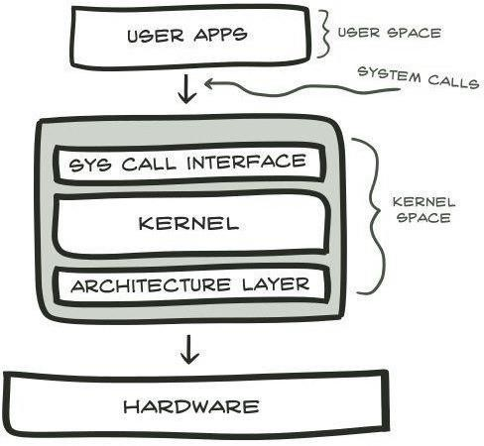
Figure 1: System call architecture. User applications sit in user space. When they need OS services (file access, process creation, etc.), they make system calls that pass through the System Call Interface into kernel space, where the kernel and architecture layer interact with the hardware.

What are System Calls?
A system call is how your program talks to the operating system kernel. Your C program runs in user mode with limited access. When it needs to do something privileged – like creating a new process, reading a file, or allocating memory – it makes a system call, which temporarily switches to kernel mode where the OS performs the operation.
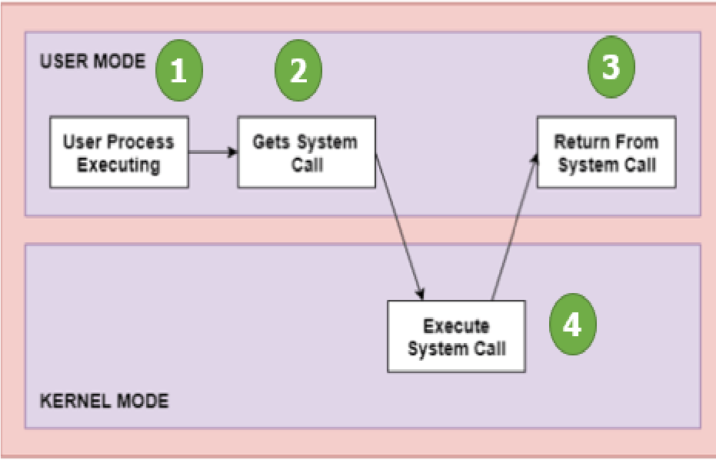
Figure 2: System call execution flow. Step 1: Process runs in user mode. Step 2: A system call is triggered (e.g., fork()). Execution switches to kernel mode. Step 3: The kernel executes the system call. Step 4: Control returns to user mode and the process resumes.

Types of System Calls
System calls are grouped into five categories:
Category | Purpose | Key Functions
Process Control | Create, terminate, and manage processes | fork(), exit(), wait(), exec()
File Management | Create, read, write, delete, and manage files | open(), read(), write(), close()
Device Management | Request, release, and interact with hardware devices | ioctl(), read(), write()
Info Maintenance | Get/set time, date, process attributes, system data | getpid(), alarm(), sleep()
Communication | Inter-process communication, shared memory, pipes | pipe(), shmget(), mmap()

Windows vs Unix System Calls
Operation | Windows | Unix/Linux
Create process | CreateProcess() | fork()
Exit process | ExitProcess() | exit()
Wait for process | WaitForSingleObject() | wait()
Open file | CreateFile() | open()
Get process ID | GetCurrentProcessID() | getpid()
Create pipe | CreatePipe() | pipe()

The fork() System Call
The fork() system call is the primary way to create a new process in Linux. When a process calls fork(), the operating system creates an exact copy of that process. The original process is called the parent, and the new copy is called the child.
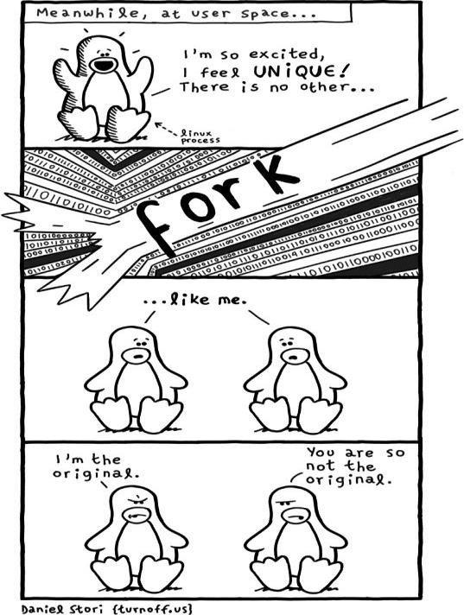
Figure 3: A humorous illustration of fork(). A Linux process thinks it’s unique, then fork() happens and an identical copy appears. Both claim to be the original! (Comic by Daniel Stori, turnoff.us)

How fork() Works
Here’s what happens step by step when fork() is called:
- The parent process calls fork()
- The kernel creates a complete copy of the parent process (including all variables, code, and open files)
- Both processes continue executing from the line after fork()
- fork() returns different values: to the parent it returns the child’s PID (a positive number), and to the child it returns 0
Return values of fork():
Return Value | Meaning | Which Process?
Positive (> 0) | The PID of the newly created child process | Parent process
Zero (0) | Indicates this is the child process | Child process
Negative (< 0) | fork() failed (not enough memory or process limit reached) | Error – no child created
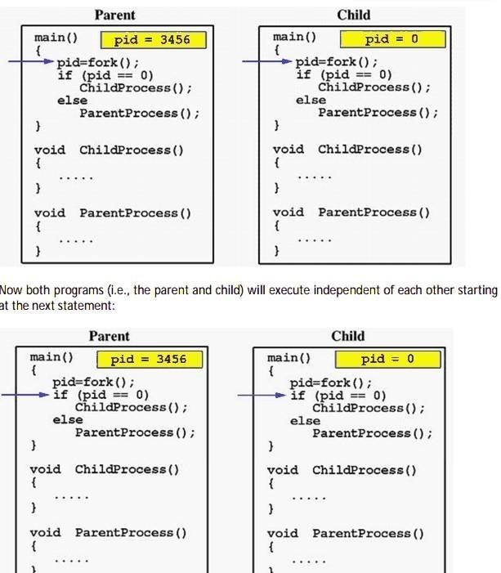
Figure 4: Visualization of fork(). The parent receives pid = 3456 (child’s PID), while the child receives pid = 0. Both check the value of pid: the child (pid == 0) runs ChildProcess(), and the parent (pid > 0) runs ParentProcess(). Both have separate copies of all variables.
OS CONCEPT: After fork(), parent and child have SEPARATE address spaces. Even though variable names are the same, changes in one process do NOT affect the other. This is because fork() copies the entire memory. Think of it like photocopying a document – writing on the copy doesn’t change the original.

Example 1: Basic fork() with Process IDs
basic_fork.c – This program creates a child process and both parent and child print their PIDs.
#include <stdio.h>
#include <sys/types.h>
#include <unistd.h>
#include <stdlib.h>

int main() {
printf("Before Checking\n");
printf("Creating child process\n");

int i = fork(); // Create child process
printf("fork() returned: %d\n", i);

if (i == 0) {
// This code runs ONLY in the child process
printf("I am a CHILD Process pid = %d, ppid = %d\n",
getpid(), getppid());
}
else if (i > 0) {
// This code runs ONLY in the parent process
printf("I am a PARENT Process pid = %d, ppid = %d\n",
getpid(), getppid());
}
else {
// fork() failed
perror("fork failed");
return 1;
}

printf("After forking\n"); // BOTH processes execute this
return 0;
}
Compile and run:
$ gcc -Wall -o basic_fork basic_fork.c && ./basic_fork
Before Checking
Creating child process
fork() returned: 3181
I am a PARENT Process pid = 3180, ppid = 3144
After forking
fork() returned: 0
I am a CHILD Process pid = 3181, ppid = 3180
After forking
INFO: Notice that "Before Checking" and "Creating child process" are printed only ONCE (before fork), but "After forking" is printed TWICE – once by each process. Everything after fork() runs in both parent and child.

Example 2: Separate Address Spaces
This example proves that parent and child have separate copies of variables. Even though both processes use a variable called y, changes in one don’t affect the other.
#include <stdio.h>
#include <sys/types.h>
#include <unistd.h>

// Function prototypes
void parent_process(int pvar);
void child_process(int cvar);

int y = 10; // Global variable (copied to both processes)

int main() {
int x = 0;
printf("Before forking\n");
printf("Creating child process\n");

int i = fork();

if (i == 0) {
child_process(x); // Child modifies its OWN copy
} else {
parent_process(x); // Parent modifies its OWN copy
}

printf("After forking\n");
return 0;
}

void child_process(int a) {
y += 2; // Child changes y: 10 + 2 = 12
a = 3; // Child sets a = 3
printf("Child: a = %d, y = %d\n", a, y);
}

void parent_process(int b) {
b = 2; // Parent sets b = 2
y += 5; // Parent changes y: 10 + 5 = 15
printf("Parent: b = %d, y = %d\n", b, y);
}
Before forking
Creating child process
Parent: b = 2, y = 15
After forking
Child: a = 3, y = 12
After forking
WARNING: The child sees y = 12 and the parent sees y = 15. They started with the same value (10) but modified their own independent copies. This is proof of separate address spaces.

Example 3: Creating Multiple Child Processes
This example creates a tree of processes using multiple fork() calls. The process tree looks like this:
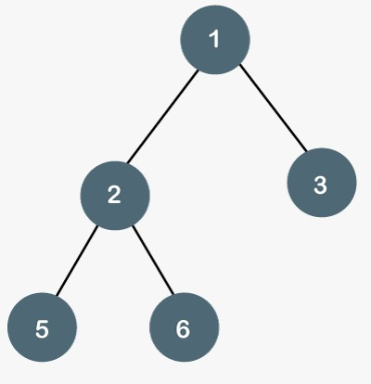
Figure 5: Process tree structure. Process 1 (original) creates children 2 and 3. Process 2 further creates children 5 and 6. Each node number corresponds to the node label printed in the code.
#include <stdio.h>
#include <unistd.h>

int main() {
printf("node:1, pid = %d, ppid = %d\n", getpid(), getppid());

int i = fork();

if (i == 0) {
// First child (node 3)
printf("node:3, pid = %d, ppid = %d\n", getpid(), getppid());
}
else {
// Parent continues, creates more children
i = fork();
if (i == 0) {
// Second child (node 2)
printf("node:2, pid = %d, ppid = %d\n", getpid(), getppid());

i = fork();
if (i == 0) {
printf("node:6, pid = %d, ppid = %d\n", getpid(), getppid());
} else {
i = fork();
if (i == 0) {
printf("node:5, pid = %d, ppid = %d\n", getpid(), getppid());
}
}
}
}
return 0;
}
TIP: Run this program and verify the parent PIDs (ppid) match the expected tree structure. Node 5 and 6 should show node 2’s PID as their parent.

System Calls to Get Process IDs
Function | Returns | Header
getpid() | The PID of the current (calling) process | <unistd.h>
getppid() | The PID of the parent of the current process | <unistd.h>

Zombie and Orphan Processes

Zombie Process
A zombie process is a process that has finished executing but still has an entry in the process table. It’s like a ghost – the process is dead, but its record hasn’t been cleaned up yet.
Why does this happen? When a child process finishes, the kernel keeps its exit status information in the process table so the parent can read it. The child becomes a zombie until the parent calls wait() to collect this information (called “reaping”).
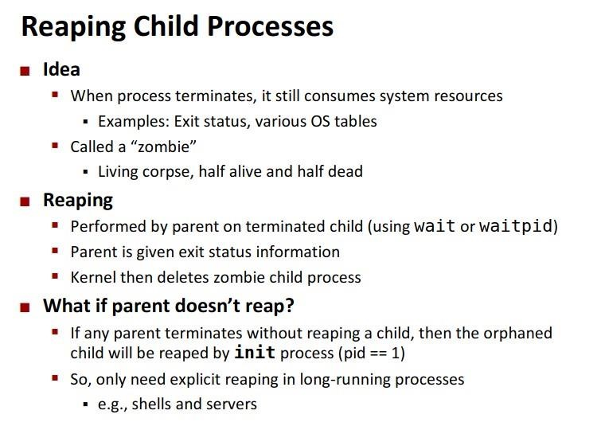
Figure 6: Zombie process concept. When a process terminates, it still consumes system resources (exit status, OS table entries) until its parent reaps it using wait() or waitpid(). If the parent never reaps it, the orphaned zombie is cleaned up by the init process (PID 1).

Example 4: Creating a Zombie Process
This program creates a child that exits immediately while the parent runs an infinite loop without calling wait() – making the child a zombie.
#include <stdio.h>
#include <unistd.h>
#include <sys/types.h>
#include <stdlib.h>

void create_zombie() {
if (fork() == 0) {
// Child: print message and exit immediately
printf("Terminating Child, PID = %d\n", getpid());
exit(0);
}
else {
// Parent: runs forever, NEVER calls wait()
printf("Running Parent, PID = %d\n", getpid());
while (1); // Infinite loop
}
}

int main() {
printf("Hello from main\n");
create_zombie();
return 0;
}
To see the zombie: Open two terminals.
- In Terminal 1, compile and run the program: ./zombie
- In Terminal 2, run: ps -al
- Look for the child process – it will show as <defunct> which means it’s a zombie
- Kill the parent to clean up: kill <parent-pid>
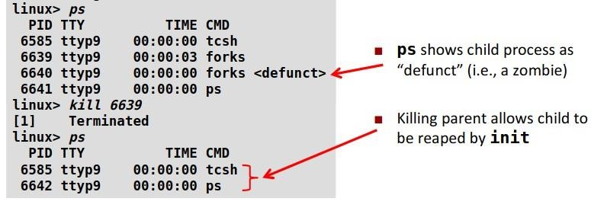
Figure 7: The ps command showing a zombie (defunct) process. After killing the parent, init adopts and reaps the zombie, cleaning up the process table.

Solution: Prevent Zombies with wait()
The solution is simple: the parent must call wait(NULL) to collect the child’s exit status. This “reaps” the zombie.
Without wait() (creates zombie):
// BAD: Parent never waits for child
int pid = fork();
if (pid > 0) {
sleep(10); // Parent sleeps
printf("Parent\n"); // Child is zombie during this time
}
With wait() (no zombie):
// GOOD: Parent waits for child to finish
int pid = fork();
if (pid > 0) {
wait(NULL); // Parent waits until child finishes
printf("Parent\n"); // Child is properly cleaned up
}
OS CONCEPT: When a process exits and its parent never calls wait(), the zombie stays in the process table. But when the parent itself eventually exits, all its zombie children are inherited by the init process (PID 1), which automatically reaps them. This is why zombies don’t persist forever – but in long-running programs like servers, un-reaped zombies can accumulate and waste resources.

Orphan Process
An orphan process is the opposite of a zombie: the parent exits first, leaving the child still running. Just like in real life, an orphan has lost its parent.
When this happens, the init process (PID 1) automatically adopts the orphan. You can verify this by checking the orphan’s ppid – it will change to 1.

Example 5: Creating an Orphan Process
#include <stdio.h>
#include <sys/types.h>
#include <unistd.h>

int main() {
int pid = fork();

if (pid > 0) {
// Parent: sleeps briefly then exits
sleep(1);
printf("Parent exiting, PID = %d\n", getpid());
// Parent exits here, child becomes an orphan!
}

if (pid == 0) {
// Child: sleeps longer than parent
sleep(5);
printf("Child running, PID = %d\n", getpid());
printf("My parent PID is now: %d\n", getppid());
// getppid() will return 1 (init) since parent is gone!
}

return 0;
}
Parent exiting, PID = 4520
Child running, PID = 4521
My parent PID is now: 1
INFO: Notice the child’s parent PID changed to 1 (the init process). This proves the child was orphaned and adopted by init. The child can still run to completion – it just has a new parent.

The exec() System Call
While fork() creates a copy of the current program, exec() replaces the current program with an entirely different one. The process ID stays the same, but the code, data, and stack are replaced with the new program.
Key point: After a successful exec() call, the code that follows it in your program will NEVER execute – because your program has been replaced. If you see code after exec() running, it means exec() failed.

The execl() Function
int execl(const char *path, const char *arg0, ..., (char *)0);

// path: Full path to the program to execute
// arg0: By convention, the program name
// ...: Additional arguments to the program
// Last: Must be (char *)0 (NULL terminator)

Example 6: Simple exec()
#include <stdio.h>
#include <sys/types.h>
#include <unistd.h>

int main() {
printf("About to run ls command...\n");

// Replace this program with /bin/ls
execl("/bin/ls", "ls", (char *)0);

// If we reach here, execl() failed!
perror("execl failed");
return 1;
}
About to run ls command...
basic_fork.c zombie.c orphan.c exec_simple.c
WARNING: The printf before execl() runs, but if execl succeeds, the perror line NEVER runs because the entire program has been replaced by /bin/ls. If you see the error message, it means execl failed (wrong path, permissions, etc.).

Example 7: fork() + exec() Together
In practice, you almost always use fork() + exec() together. The parent forks a child, and the child uses exec() to run a different program. This way the parent doesn’t get replaced.
#include <sys/types.h>
#include <unistd.h>
#include <stdio.h>
#include <stdlib.h>
#include <string.h>
#include <sys/wait.h>

int main() {
int PID;
char cmd[256];

printf("Press 'e' to quit. Type a command to execute.\\n");

while (1) {
printf("cmd: ");
scanf("%s", cmd);

if (strcmp(cmd, "e") == 0)
exit(0); // User wants to quit

PID = fork();

if (PID > 0) {
// Parent: wait for child to finish
wait(NULL);
}
else if (PID == 0) {
// Child: replace itself with the command
execlp(cmd, cmd, NULL);

// Only reached if exec failed
fprintf(stderr, "Cannot execute %s\n", cmd);
exit(1);
}
else {
fprintf(stderr, "Cannot create a new process\n");
exit(2);
}
}
}
TIP: This is essentially a mini shell! It reads a command name, forks a child, and the child uses execlp() to run that command. The parent waits for the child to finish before asking for the next command. This is how real shells (like bash) work internally.

Process System Calls – Quick Reference
System Call | Header | Purpose
fork() | <unistd.h> | Create a new child process (copy of parent)
getpid() | <unistd.h> | Get the PID of the current process
getppid() | <unistd.h> | Get the PID of the parent process
wait(NULL) | <sys/wait.h> | Wait for any child to finish (prevents zombies)
execl() | <unistd.h> | Replace current process with a new program (by path)
execlp() | <unistd.h> | Replace current process with a new program (searches PATH)
exit(status) | <stdlib.h> | Terminate the current process with a status code
sleep(secs) | <unistd.h> | Pause execution for the specified number of seconds
— End of Lab 05 —

